Grossmont College Name: _______________________
Chemistry 102, Fall 2015
Quiz 4 (20 points) Date: ____________

- (10 points). An ice cube of mass 9.0 g at temperature 0 °C is added to a cup of coffee, whose temperature is 90 °C and which contains 110 g of liquid. Assume the specific heat capacity of coffee is the same as that of water (4.184 J/g °C). The heat of fusion of ice (the heat associated with ice melting) is 6.0 kJ/mol. Find the temperature of the coffee after the ice melts

- (6 points) Pentaborane-9, B₅H₉, is a colorless, highly reactive liquid that will burst into flame when expoed to oxygen. The reaction is

2 B₅H₉(l) + 12 O₂(g) 5 B₂O₃(s) + 9 H₂O(l)

- Calculate ΔH_{rxn}º

- Calculate the amount of energy released when a 15.00 g simple of pentaborane-9 is burned in the presence of oxygen.

$$'$$
- (4 points) Use bond energies to calculate the heat of reaction for CO₂ + 2 NH₃ NH₂CONH₂ + H₂O The molecular structures are shown below:

ΔH_{f}º, B₅H₉(l) = 73.2 kJ/mol ΔH_{f}º, B₂O₃(s) = −1263.6 kJ/mol
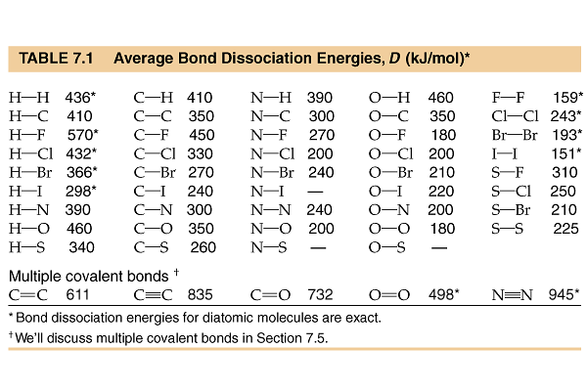
ΔH_{f}º, H₂O(l) = −285.8 kJ/mol ΔH_{f}º, H₂O (g) = −-241.8 kJ/mol

